# Things to consider before designing the PCB layout:

* Set up the Design Rules to correspond with the intended attributes of the board. This may include:
  + Design rules comply with the manufacturer’s capabilities.
  + Trace width for each circuit. Compensate for copper thickness.
  + Electrical spacing suitable for voltage levels?
  + Altitude considerations?
  + High Frequency circuits?
* Refer to the documentation of each component used and review the suggested layout and recommended complementary components.
* Will this board be assembled by the manufacturer? See “Design for Assembly”
* Is it possible to mount all SMD components on a single side?

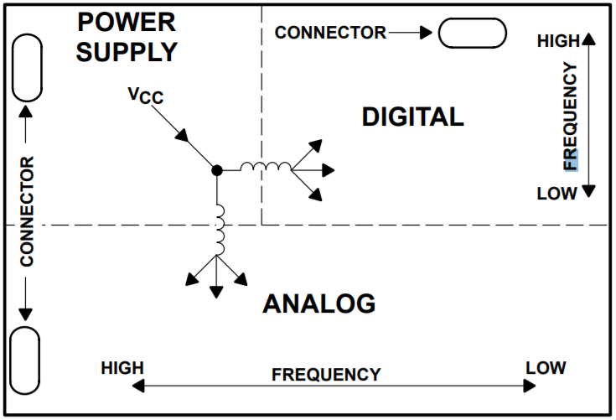

# Things to accompany the fabrication files:

* Power demand calculations.
* Component BOM and datasheets if applicable.
* List of desired manufacturers and what PCB specifications were considered in the design? Track spacing, copper weight, surface finish etc.

|  |  |
| --- | --- |
| Board: | NiCd 10 Cell Battery Tester Rev 3 |
| Reviewed By: | Date: |
| Riley | April 23 2021 |
|  |  |

# Schematic Review

|  |  |  |  |
| --- | --- | --- | --- |
| Item | Description | Yes/No | Comments |
| 1.1 | Do all the chips on the board have bypass and/or filter capacitors, and are they placed as close as possible to the power pins? | YES |  |
| 1.2 | Are unused input pins properly pulled or tied to their desired logic levels and not left floating? | N/A |  |
| 1.3 | Have the single source components in the design been identified? Where possible, have components been selected using the most common industry standard packages allowing for second source alternatives? | OK |  |
| 1.4 | Has the bill of material been reviewed to minimize the number of unique components in the design? | OK |  |
| 1.5 | Have the voltage ratings for capacitors and other passives been verified? At least 1.5x to 2x the operating voltage. | YES |  |
| 1.6 | Has a power budget been completed for this board? Are the LDO regulators able to supply the load current without excessive heat loss? | YES |  |
| 1.7 | Do connectors exposed to the outside world have adequate ESD/TVS protection? | NO |  |
| 1.8 | Do all active components have Power and Ground connected? Are they connected to the correct power and grounds? | YES |  |
| 1.9 | Have timing crystals been connected with the appropriate resonance capacitors? Have oscillators’ internal capacitors been grounded appropriately? | N/A |  |

# Part Design

|  |  |  |  |
| --- | --- | --- | --- |
| Item | Description | Yes/No | Comments |
| 2.1 | Have the pin assignments in the schematic been verified against the part datasheets? | YES |  |
| 2.2 | Have the mechanical dimensions been verified for all the component footprints? | YES |  |
| 2.3 | Are any component datasheets showing the pin assignments from the bottom perspective? If so, is this accounted for? | NO |  |
| 2.4 | Are the drill sizes for all the through hole components large enough, or too large, for the pin diameters? | YES |  |
| 2.5 | Has the pin order been verified on all the connectors? Also take into consideration if the mating cable reverses the pin order. | YES |  |
| 2.6 | Are the connectors adequately keyed to prevent backwards cable insertion? | N/A |  |
| 2.7 | Have passive values been consolidated to minimize unique parts? (e.g. do you really need a 10k and a 12k resistor in the design?) | OK |  |
| 2.8 | Have tuned values (e.g. amplifier or regulator feedback circuits) been tweaked to E12 or E24 series values where feasible? | OK |  |

# PCB Mechanical

|  |  |  |  |
| --- | --- | --- | --- |
| Item | Description | Yes/No | Comments |
| 3.1 | Have the dimensions of the mating cables been considered when spacing the PCB connectors? Has finger access to cables been considered in the connector spacing? | OK |  |
| 3.2 | If the circuit board is going into an enclosure, are the connectors positioned to be flush with the enclosure outer surfaces? | N/A |  |
| 3.3 | If the circuit board is going into a tight fitting enclosure, have component heights and other mechanical keepouts been accounted for? | N/A |  |
| 3.4 | Are the mounting holes in logical and the correct locations, and are their diameters correct for the intended mounting screws with plating thickness accounted for? Are the mounting hole diameters also correct (not too large) when considering the outer diameter of the enclosure standoffs? | YES |  |
| 3.5 | Do components and traces have adequate spacing away from mounting holes to account for the screw head diameter or potential damage due to a drill bit slipping during assembly? | YES |  |
| 3.6 |  |  |  |
| 3.7 |  |  |  |

# Silkscreen

|  |  |  |  |
| --- | --- | --- | --- |
| Item | Description | Yes/No | Comments |
| 4.1 | Does the silk screen include company name, project number, part number, and PCB revision? | YES |  |
| 4.2 | Are all the silk screen labels oriented uniformly or in only two orientations? | YES |  |
| 4.3 | Are all the silk screen labels clear of solder pads and via drills? | YES |  |
| 4.4 | Do all the passive components with placement orientation (electrolytic capacitors, diodes, LEDs, etc) have adequate silkscreen markings to indicate the install polarity? | YES |  |
| 4.5 | Is pin 1 marked on all ICs where incorrect rotation is possible? | YES |  |
| 4.6 | Do connectors have pin numbers or markings that show the pin or connector usage and will remain legible when the connector is installed? | YES |  |
| 4.7 | Any additional information required on the silkscreen to aid the user? Legend, replacement parts, etc. | OK |  |
| 4.8 | Are the test points or critical circuits labelled? | YES |  |
| 4.9 | Do component labels far from their components have a line, arrow or logical arrangement that indicates which component they refer to? | OK |  |
| 4.10 | Are fuses’ rating and type listed on the board? | YES |  |
| 4.11 | In the case of insufficient space to label all components, have the most important components been given priority?  Generally:   1. Connectors 2. Fuses (including rating) 3. ICs 4. Crystals 5. Test points 6. Tuned passives (i.e. amplifier or regulator feedback circuits) 7. Termination resistors/capacitors 8. Bypass Capacitors 9. Pullup/down resistors | OK |  |

# Copper Design

|  |  |  |  |
| --- | --- | --- | --- |
| Item | Description | Yes/No | Comments |
| 5.1 | Does the PCB layout software confirm that all nets are 100% routed? | YES |  |
| 5.2 | Have the PCB design rules been configured to comply with the manufacturer’s minimum spacings and feature sizes? | YES |  |
| 5.3 | Does the PCB layout software Design Rule Check pass? | YES |  |
| 5.4 | Have all the pads been verified as having good pad exits; no traces exiting at unusual acute angles? | YES |  |
| 5.5 | Are all the high current traces accounted for? Do they use sufficient copper width to handle the current? | YES |  |
| 5.6 | Do all components through holes and SMD solder pads have thermal isolation (wagon wheels) from ground planes and copper pours? | YES |  |
| 5.7 | Do high power components have adequate heat sinking using PCB copper heatsink or mechanical heat sink? | YES |  |
| 5.9 | Does the ground fill meet up with all of the desired grounded nets? No isolated islands of copper? | OK |  |
| 5.10 | High power or noisy traces do not run near sensitive components or traces for such components? | OK |  |
| 5.11 | Multiple vias for high current or low impedance circuits? Impedance of critical traces has been calculated and is acceptable. | YES |  |
| 5.12 | Are switched mode power supplies laid out per the manufacturer datasheet recommendations? Is loop area minimized for resonant current loops? | N/A |  |
|  |  |  |  |

# Design for Assembly

|  |  |  |  |
| --- | --- | --- | --- |
| Item | Description | Yes/No | Comments |
| 6.1 | Does the PCB have at least 3 fiducials? | YES |  |
| 6.2 | Are surface mount components used wherever possible instead of through holes? This improves assembly automation, quality, and manufacturing cost. | YES |  |
| 6.3 | For all through hole components, are the bottom side copper rings nice and wide to allow for easy wave/hand soldering? Pins that are tight pitch can use ovals or rectangular annular rings. | YES |  |
| 6.4 | Are bottom side SMT components appropriately spaced away from through hole pins? | N/A |  |
| 6.5 | Do all traces and components have sufficient clearance away from the edge of the board? | YES |  |
| 6.6 | Panel design required? | NO |  |
| 6.7 |  |  |  |

# Design for Test

|  |  |  |  |
| --- | --- | --- | --- |
| Item | Description | Yes/No | Comments |
| 7.1 | Does the circuit board have sufficient test points and locations for probing of critical signals and monitoring supply voltages? Are there convenient locations for attaching the probe leads? | YES |  |
| 7.2 | Does the board include adequate structures or connectors for firmware load or functional test? | N/A |  |
| 7.3 | If the board is intended for high volume manufacturing, does the design include bottom side solder mask openings to allow for a bed of nails in-circuit test? | N/A |  |
| 7.4 | Can the board be easily debugged? Critical circuits can be measured from a single side or when installed in the intended position? | YES |  |
| 7.5 |  |  |  |
| 7.6 |  |  |  |

# High Speed Signals

|  |  |  |  |
| --- | --- | --- | --- |
| Item | Description | Yes/No | Comments |
| 8.1 | Are traces carrying high speed signals designed as transmission lines using appropriate PCB impedance? | N/A |  |
| 8.2 | Do high speed signals use the correct terminations as suggested by the part manufacturer? | N/A |  |
| 8.3 | Are high speed signals routed over solid unobstructed copper planes? | N/A |  |
| 8.4 | Are high speed differential pairs routed using proper symmetry and length matching? | N/A |  |
| 8.5 | Are traces spaced and routed to minimize crosstalk? | N/A |  |
| 8.6 |  |  |  |

# PCB Fabrication

|  |  |  |  |
| --- | --- | --- | --- |
| Item | Description | Yes/No | Comments |
| 9.1 | Are the fabrication files up to date? |  |  |
| 9.2 | Are all the fabrication files in the zipped folder? Drill files, GERBERS, etc. |  |  |
| 9.3 | Does the Design Rule Check pass without warnings or errors? | YES |  |
| 9.4 | Has the list of desired manufacturers and what PCB specifications were considered in the design been reviewed and adhered to? |  |  |
| 9.5 |  |  |  |
| 9.6 |  |  |  |
| 9.7 |  |  |  |

# Notes